Airports, Carrier, Plane Info,Flights

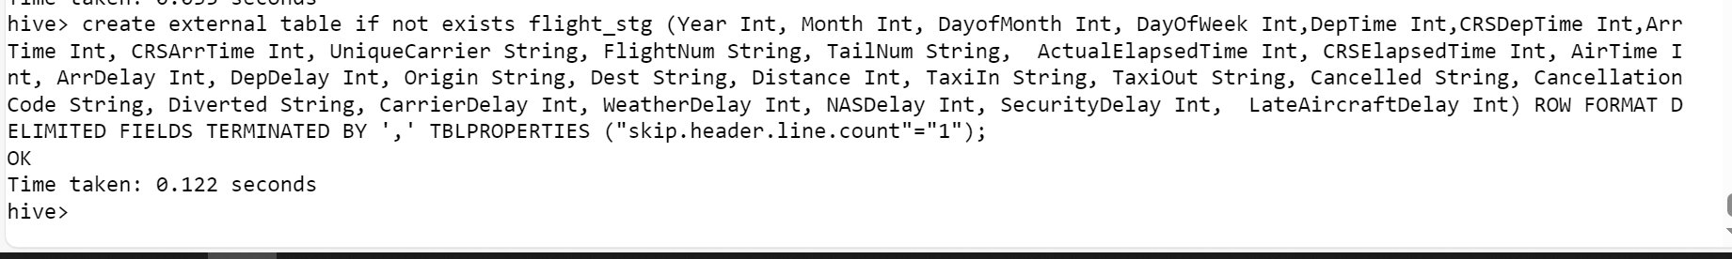

1. Data Setup in HDFS

Step 1: Copy the provided csv files in a directory named AirlinesOntimeAnalysis

Step 2: Unzip the contents for the bz2 files. Note => compressed to decompressed

Step 3: Create the directories in hdfs where your data will reside

Step 4: copy the respective files to the above created hdfs structure

2. Create tables using Hive

1. Improving the performance of Hive tables - Parquet format

Loading the data =>

What is the average arrival delay and average departure delay in each month of the year 2004?

